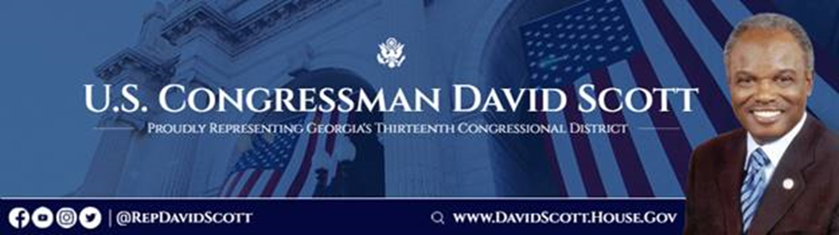

Rep. David Scott (GA-13)
FY 2024 Community Project Funding Request Application
SUBMISSION DEADLINE: COB Monday, March 20, 2023

Instructions and Requirements

- Please read carefully the information below regarding the specific appropriations accounts that remain eligible for Community Project Funding (CPF) requests and ensure that your request fits within one of those accounts.

- Include ONE submission per form. No more than 2 submissions per requesting organization.

- All requests must be for a one-time, single-year allocation of funds.

- Completed forms should be emailed to GA13earmarks@mail.house.gov no later than Monday, March 20, 2023.

- Ensure that all questions on the form are completed.

- Include a letter on your entity’s official letterhead making the request.

Please note that all submitted forms are subject to public disclosure.

Appropriations Accounts Eligible for Community Project Funding in FY2024

For FY24, the appropriations accounts listed below remain eligible for Community Project Funding. Please click on the hyperlinks for more information about each account.

Agriculture, Rural Development, Food and Drug Administration, and Related Agencies
- Department of Agriculture–Farm Production and Conservation Programs
  - Natural Resources Conservation Service (Conservation Operations)
- Department of Agriculture–Research, Education, and Economics
  - Agricultural Research Service (Buildings and Facilities)
- Department of Agriculture–Rural Development
  - Rural Housing Service (Community Facilities)
  - Rural Utilities Service (ReConnect Program)
  - Rural Utilities Service (Distance Learning and Telemedicine Grants)
  - Rural Utilities Service (Rural Water and Waste Disposal Grants)

Commerce, Justice, Science, and Related Agencies
- Department of Commerce
  - NIST—Scientific and Technical Research
  - NOAA—Coastal Zone Management
- Department of Justice
  - COPS Technology and Equipment
  - Byrne Justice
- National Aeronautics and Space Administration
  - Safety, Security, and Mission Services

Energy and Water Development
- Army Corps of Engineers (Civil Works)
  - Investigations
  - Construction
  - Mississippi River and Tributaries
  - Operation and Maintenance
- Department of the Interior/Bureau of Reclamation
  - Water and Related Resources

Homeland Security
- Federal Emergency Management Agency
  - Federal Assistance—Emergency Ops. Centers
  - Federal Assistance—Pre-Disaster Mitigation

Interior, Environment, and Related Agencies
- Environmental Protection Agency
  - STAG—Clean Water State Revolving Fund
  - STAG—Drinking Water State Revolving Fund

Military Construction, Veterans Affairs, and Related Agencies
- Army
- Army National Guard
- Army Reserve
- Navy & Marine Corps
- Navy Reserve
- Air Force and Space Force
- Air National Guard
- Air Force Reserve
- DoD, Defense-Wide

Transportation, and Housing and Urban Development, and Related Agencies
- Department of Housing and Urban Development
  - CDBG – Economic Development Initiatives
- Department of Transportation
  - Airport Improvement Program
  - Highway Infrastructure Projects
  - Transit Infrastructure Projects
  - Consolidated Rail Infrastructure and Safety Improvements
  - Port Infrastructure Development Program

Section One: Contact

Requesting Entity
Official name of requesting entity:
Type of entity (non-profit, university, government, etc.):
Address:
Phone number:
Website:

Point of Contact for Requesting Entity:
Name:
Title:
Address:
Phone number:
Email address:

Intermediary Contact (if applicable)
Name:
Title:
Organization:
Address:
Phone number:
Email address:

Section Two: Official Request

Bill (e.g., Agriculture; CJS, Defense, T-HUD):

Account (must be one of the specific accounts listed above):

Suggested Title of Request:

Detailed description of funding request:

Dollar amount requested (smaller requests are more likely to be funded):

Please provide a detailed spend plan and itemized budget (attach if needed) for the requested funding, breaking down anticipated expenditures for each major category of project activity:

How this request, if funded, will help GA-13, the State of Georgia more broadly, and the nation:

Describe the current status of this project; describe any previous requests you have made for government (federal, state, local) funding; and confirm that, if funding is provided, the project can be implemented swiftly and effectively:

Please outline what supporting materials you have to demonstrate community need and community support for this project (and attach documents, including at least two letters of support)

Please use this space to input any additional information that is required/requested pursuant to the account-specific Appropriations Committee instructions. Please strictly adhere to the relevant Submission Guidance documents that are hyperlinked on Page 2 and 3 of this document:

